**Visit our store**

*https://www.aliexpress.com/store/1101430866?spm=a2g0o.store_pc_home.1000001.12.15e84534WdGboE*

content

目录

1. Product Brief 5

1.1 Features and advantages 6

1.2 Motherboard parameters 8

1.3 Wiring diagram 9

1.4 Dimensions 9

2. Firmware 10

Firmware download 10

2.1 Firmware compilation 10

2.2 Firmware upload 11

3. Drive subdivision setting 12

3.1 A4988 driver subdivision settings 12

3.2 TMC2208, TMC2209, TMC2226 common mode Settings 13

3.3 TMC2225 normal mode setting 14

4. Marlin firmware configuration 15

4.1 Basic firmware configuration (must configure items) 15

4.1.1 Motherboard configuration 15

4.1.2 Serial port configuration 16

4.1.3 Screen configuration 18

4.1.4 Enable SD card 21

4.1.5 Enable eeprom 21

4.1.6 Compile environment configuration 22

4.2 Machine parameter configuration (set according to machine parameter) 22

4.2.1 Number of extrusion heads configuration 22

4.2.2 Thermal type configuration 23

4.2.3 Enstop level type configuration 24

4.2.4 Pulse setting 25

4.2.5 Zero return direction setting 26

4.2.6 Print platform range setting 26

4.2.7 Motor direction setting 26

4.3 Advanced configuration 27

4.3.1 POWER_LOSS_RECOVERY 27

4.3.2 FILAMENT_RUNOUT_SENSOR 28

4.3.3 WIFI configuration 32

5. 3dtouch automatic leveling function 32

5.1 Set the sensor trigger level 32

5.2 Set sensor signal pin 33

5.3 Enable BLTOUCH 35

5.4 Set the offset between the probe and the extrusion 35

5.5 Set the distance between the sensor and the edge of the printing platform during leveling 36

5.6 Enable automatic leveling 37

5.7 Set the number of grid points for leveling 37

5.8 Enable the servo 38

5.9 Add auto-leveling data enable code 38

6. WEB connection and settings 40

7、FAQ 44

# Product Brief

MKS TinyBee V1.0 motherboard is a 32-bit main control board launched

by the makerbase team to meet market needs. The motherboard supports wifi function without additional wifi module, supports web page control, supports LCD2004, LCD mini12864, MKS mini12864 V3. 0, LCD12864,

support serial screen control

## Features and advantages

1. Support wifi control and wireless file transfer;
2. The driver subdivision setting is the dial code setting, which is more convenient for the driver subdivision setting;
3. The main board PCB adopts immersion gold technology, which has better stability;
4. The user can replace the motor drive by himself, supporting 4988, 8825, 8729, TMC2208, TMC2209, TMC2225, TMC2226;
5. Reserve an external drive signal, and an external large drive can be used to drive 57 and 86 motors;
6. Using high-quality MOSFET tubes, the heat dissipation effect is better, and the long-term work is stable;
7. Use a dedicated power chip, support 12V-24V power input, and solve the problem of heating and insufficient power supply of the Ramps voltage conversion chip;
8. The stable and reliable filter circuit greatly reduces the possibility of interference, and avoids crashes and random running during the printing

process to the greatest possible extent;

1. Adopting CH340 serial port chip, under the premise of ensuring stability and reliability, reducing costs, and also solving the problem of difficult driver installation in the past 16U2;
2. Use the open source firmware Marlin2.0.X firmware;
3. Support LCD2004, LCD12864, MKS MINI12864 V1.0, MKS MINI12864 V3.0, support TFT24, TFT28, TFT32, TFT35, H43 touch screens developed by makers;
4. The XYZ axis uses different color terminals to correspond to the motor and limit switch, which is convenient for wiring;
5. Support 3dtouch;
6. Onboard TF card holder, offline printing is more stable;

## Motherboard parameters

|  |  |  |  |
| --- | --- | --- | --- |
| **Motherboard**  **type:** | **MKS TinyBee V1.0** | **microproce**  **ssor:** | **ESP32-WROOM-32U** |
| **physical** | 110*84 | **Mounting** | 102*76 |
| **dimension:** |  | **hole size:** |  |
| **Input voltage:** | 12V~24V 5A~15A | **motor** | 2208,2209,2225,2226,49 |
|  |  | **driver:** | 88,8825,8729 |
| **Temperature** | NTC 100K | **Support** | LCD2004、LCD12864、 |
| **sensor interface:** |  | **LCD/touch** | MKS MINI12864 V1.0、 |
|  |  | **screen** | MKS MINI12864 V3.0、 |
|  |  |  | MKS Series touch screen |
| **Support print file** | G-code | **Support** | XYZ、delta、kossel、 |
| **format:** |  | **machine** | Ultimaker、corexy |
|  |  | **structure:** |  |
| **Recommended** | Cura、Simplify3d、 | **Firmware** | Update via USB |
| **software:** | Pronterface、Repetier-Host | **update:** | connection to computer |

* 1. **Wiring diagram**

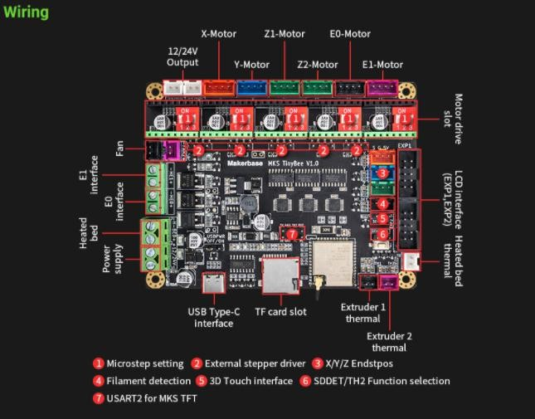

## Dimensions

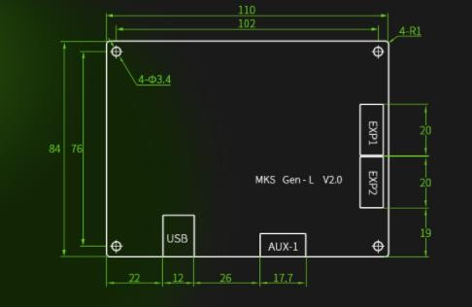

# Firmware

# Firmware download

https://github.com/Macrobase-tech/MKS-TinyBee

## Firmware compilation

Firmware compilation:

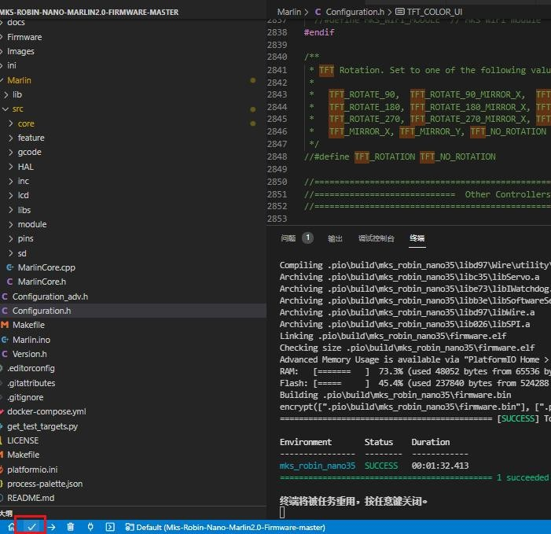After the firmware configuration is complete, click "✔" in the lower left corner of the VScode page to start compiling.

## Firmware upload

After the firmware is compiled, click "→" in the lower left corner of the VScode page to start uploading the firmware.

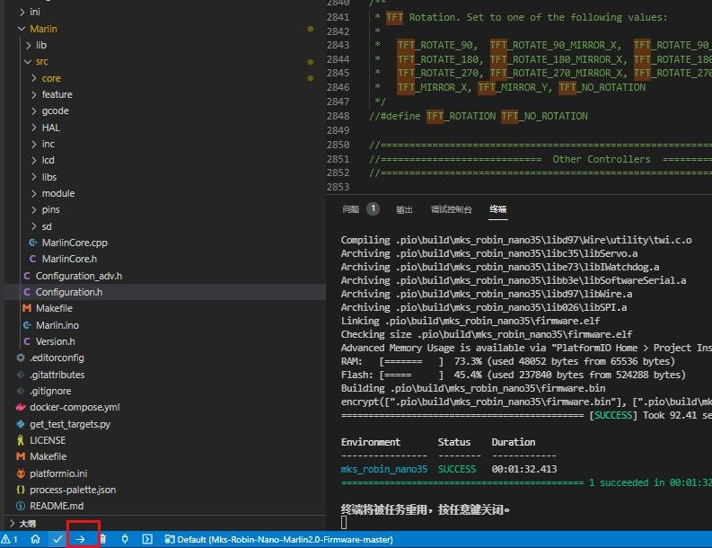

# Drive subdivision setting

## A4988 driver subdivision settings

A4988 drives the subdivision setting, the three dials below the drive are dialed up to 16 subdivisions, as shown in the figure below (X-axis as an example):

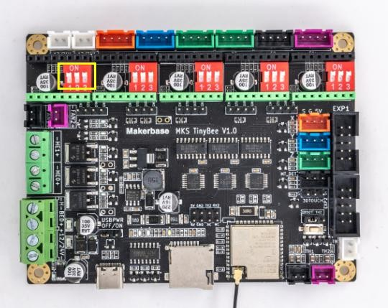

## TMC2208, TMC2209, TMC2226 common mode Settings

TMC2208, TMC2209, TMC2226 drive the three dial codes below to dial up to 16 subdivisions, as shown in the following figure (X-axis as an example):



## TMC2225 normal mode setting

TMC2225 drives the subdivision setting. Drive the second dial below to dial up, and the first and third dials down are 16 subdivisions, as shown in the figure below (X-axis as an example):

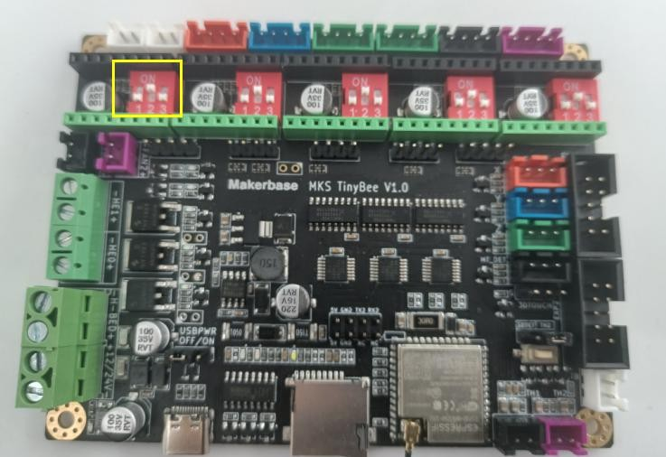

# Marlin firmware configuration

## Basic firmware configuration (must configure items)

## Motherboard configuration

Configure the board in the configuration.h file as BOARD_MKS_TINYBEE

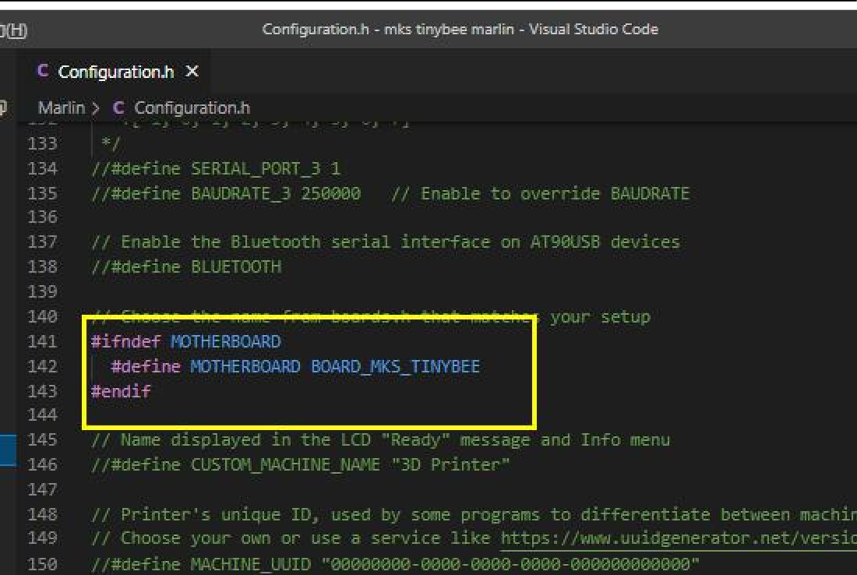

## Serial port configuration

Set the first serial port to 0 in the configuration.h file, the configuration error will cause the motherboard to be unable to connect to the computer; the second serial port is configured to -1, the web page will not be able to obtain the motherboard temperature information if the configuration error is incorrect; then baud The rates are all set to 115200.

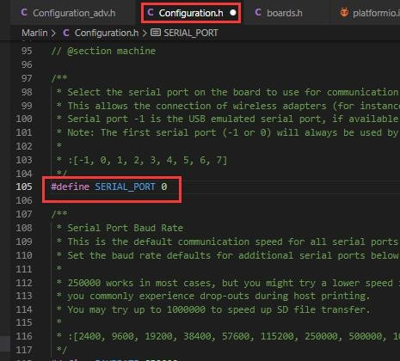

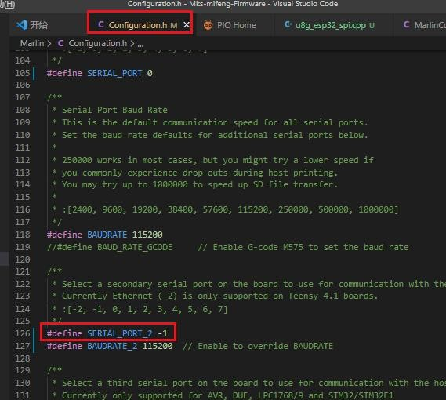

## Screen configuration

(Note: LCD screen can only enable one of the following screens, enabling multiple at the same time will cause compilation error)

1. LCD 2004 configuration, enable in the configuration file #define REPRAP_DISCOUNT_SMART_CONTROLLER

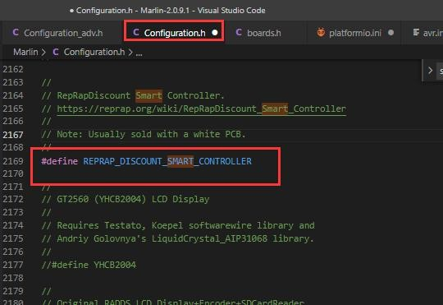

2、LCD12864 screen configuration, enabled in the configuration file #define REPRAP_DISCOUNT_FULL_GRAPHIC_SMART_CONTROLLER

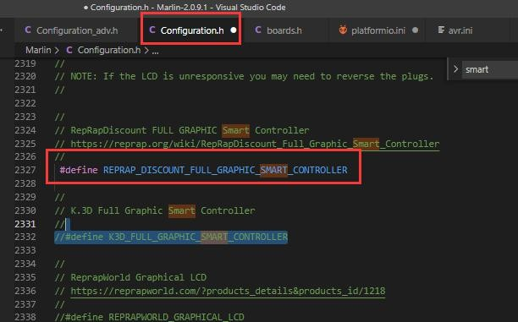

1. MKS MINI12864 V1.0 screen configuration

Enable in the configuration file#define MKS_MINI_12864

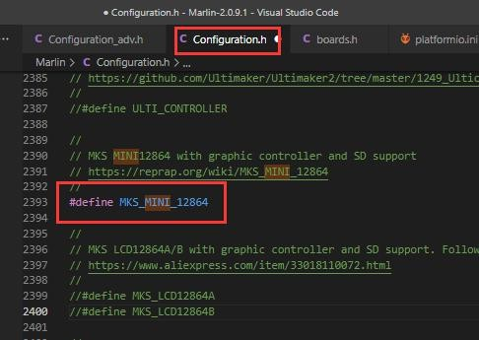

1. MKS MINI12864 V3.0 screen configuration

Enable in the configuration fileMKS MINI12864 V3

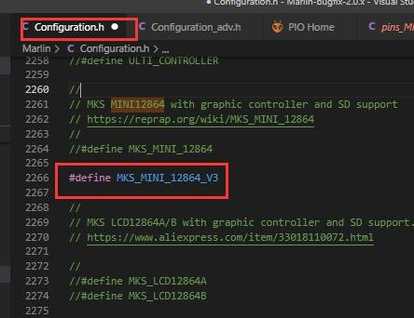

Enable RGB in the configuration file

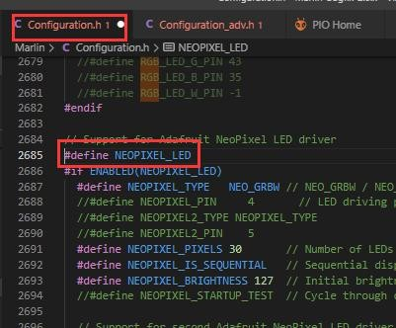

* + 1. Enable SD card

Enable #define SDSUPPORT in the configuration file

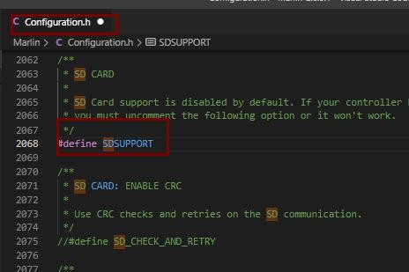

## Enable eeprom

Enable in the configuration file#define EEPROM_SETTINGS

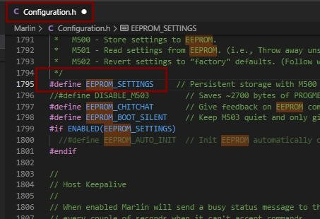

## Compile environment configuration

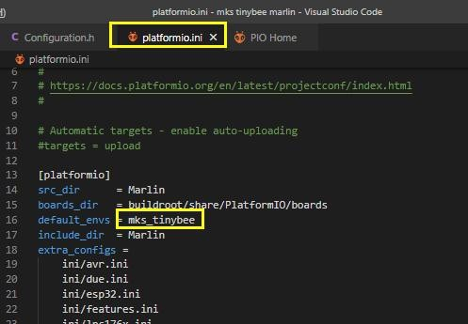Configure the compilation environment in the paltformio.ini file as mks_tinybee

## Machine parameter configuration (set according to machine parameter)

## Number of extrusion heads configuration

MKS TinyBee V1.0 supports up to 2 extruders. When using dual extruders, you need to insert the extruder 2 thermal and SD card detection pin jumper on the motherboard to the right.

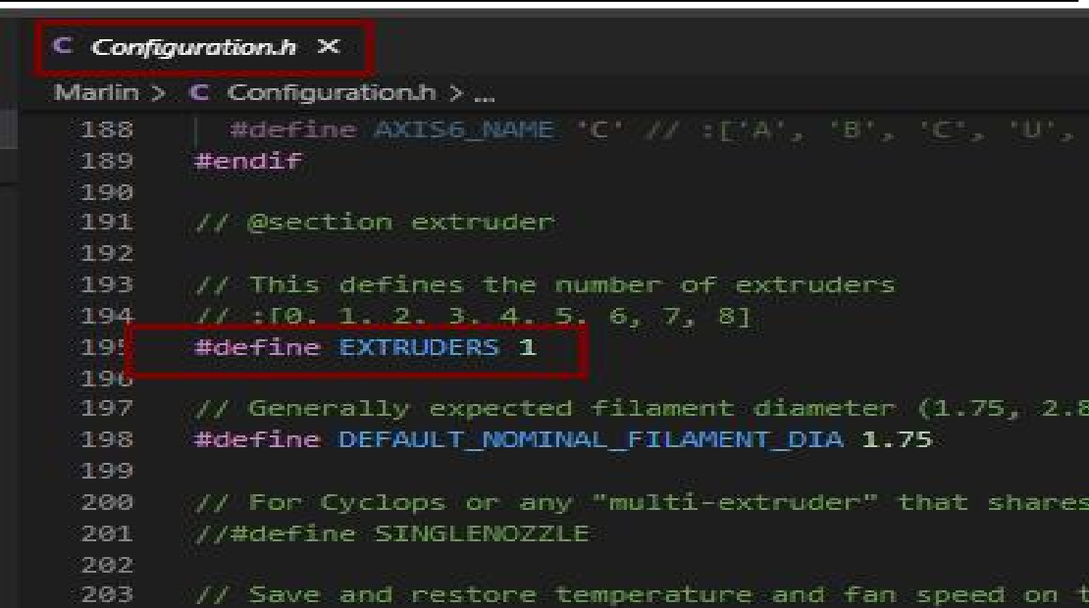

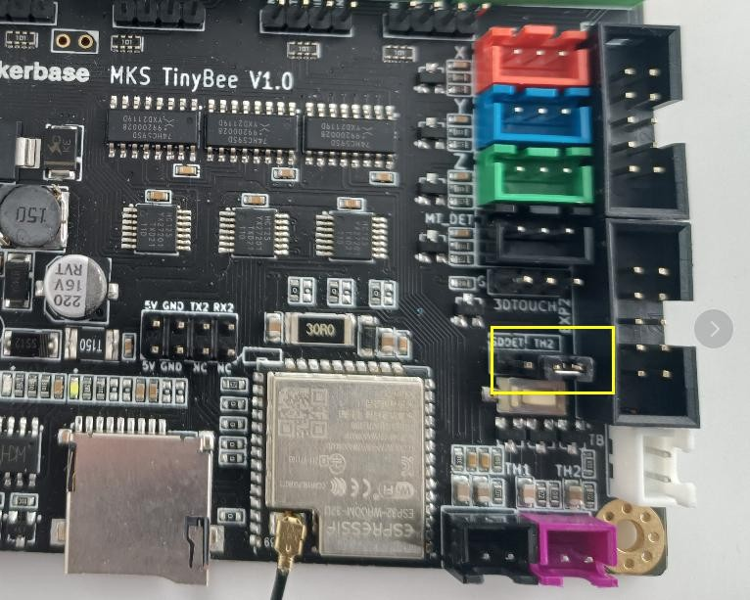

## Thermal type configuration

MKS TinyBee V1.0 motherboard only supports 100K thermal sensitivity,

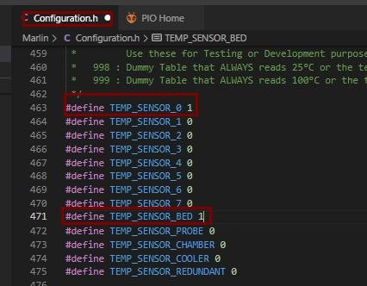#define TEMP_SENSOR_0 is extrusion head 1, #define TEMP_SENSOR_1 is extrusion head 2, #define TEMP_SENSOR_BED is hot bed

## Enstop level type configuration

The configuration of the limit switch type (true/false), true is a normally open switch, and false is a normally closed switch.

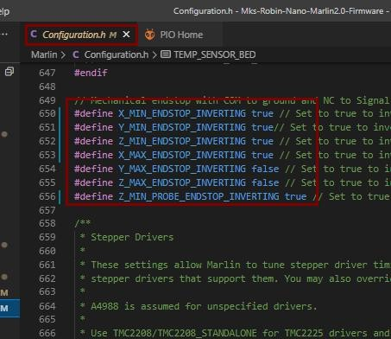

## Pulse setting

#Define DEFAULT_AXIS_STEPS_PER_UNIT {80, 80, 400, 93} in the

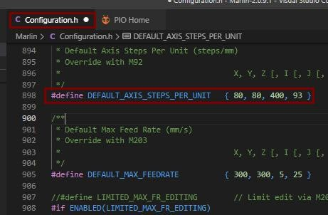configuration file to set the pulses of the X, Y, Z, and E axes respectively. The pulse value needs to be calculated and set according to the actual situation of the machine.

## Zero return direction setting

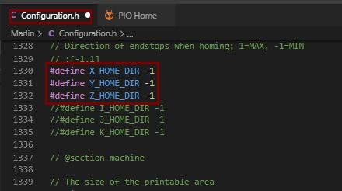Set the gohoming direction in the configuration file, -1 is the minimum direction, 1 is the maximum direction

## Print platform range setting

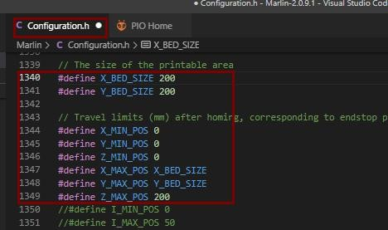

## Motor direction setting

Motor direction setting, false and true represent two rotation directions,

when the moving direction is opposite, the opposite configuration is enough.

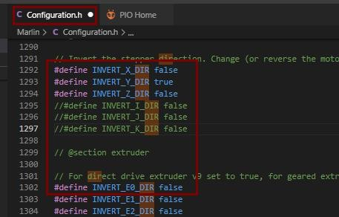

## Advanced configuration

## POWER_LOSS_RECOVERY

In the advanced configuration configuration_adv.h file, enable #define POWER_LOSS_RECOVERY Change #define PLR_ENABLED_DEFAULT to false

#Define PLR_ENABLED_DEFAULT true

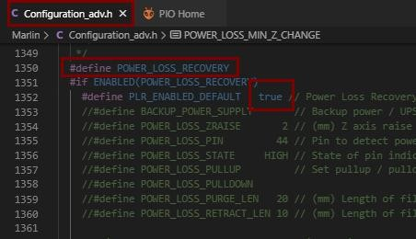

## FILAMENT_RUNOUT_SENSOR

Enable #define FILAMENT_RUNOUT_SENSOR in the configuration file

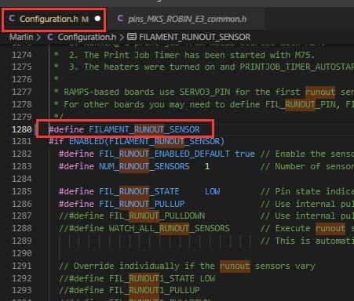

Set the level of the detection switch in the configuration file

（LOW/HIGH)

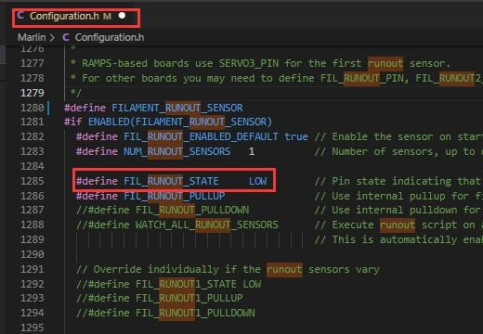

Enable#define NOZZLE_PARK_FEATURE in the configuration file

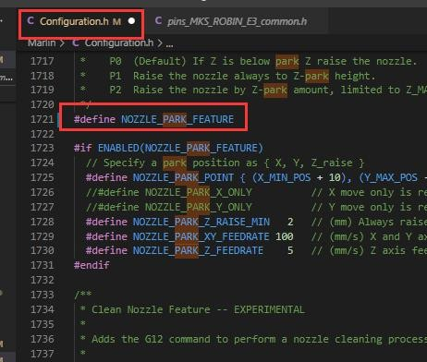

Enable#define ADVANCED_PAUSE_FEATURE in advanced configuration file

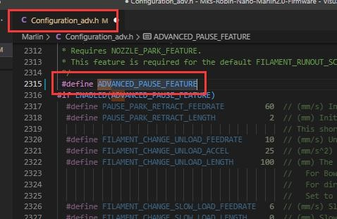

Enable #define PARK_HEAD_ON_PAUSE in advanced configuration file

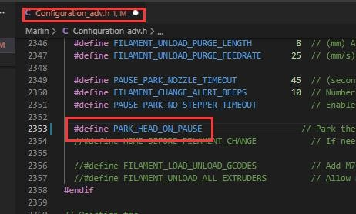

## WIFI configuration

Enable#define ESP3D_WIFISUPPORT and #define WEBSUPPORT， #define OTASUPPORT， #define WIFI_CUSTOM_COMMAND in advanced configuration file

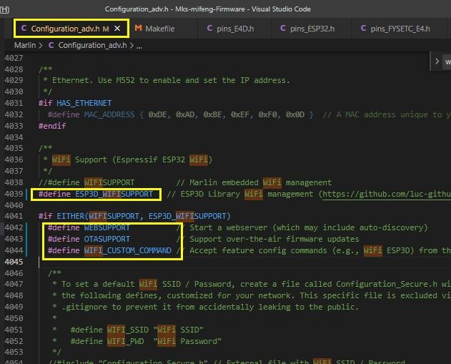

# 3dtouch automatic leveling function

## Set the sensor trigger level

The level of 3dtouch is set to false

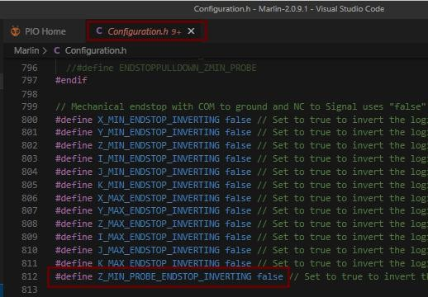

## Set sensor signal pin

There is only z_min enstop interface on the motherboard, so z_safe_homing needs to be enabled when 3Dtouch is used for automatic leveling Port.

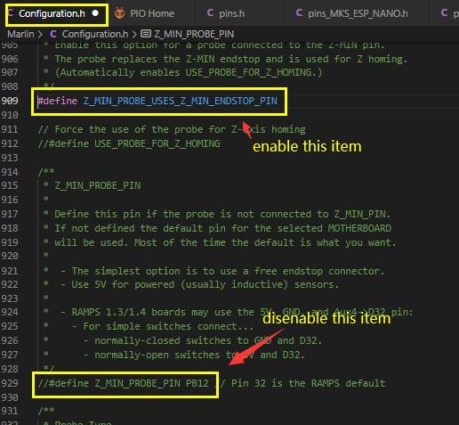

## Enable BLTOUCH

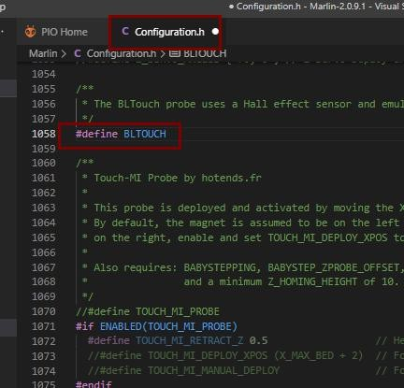

## Set the offset between the probe and the extrusion

They are the offsets of the X, Y, and Z axes. The offsets of X and Y need to be filled in according to the actual measurement. Z_offset can be tested and adjusted after leveling.

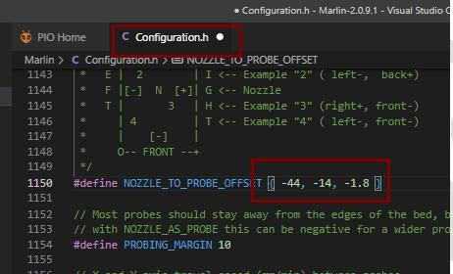

## Set the distance between the sensor and the edge of the printing platform during leveling

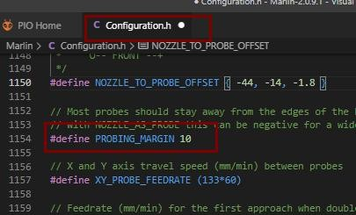The default value is 10 (Note: This value cannot be set too small, too small will cause the sensor to exceed the range of the platform during leveling, resulting in leveling failure)

## Enable automatic leveling

Enable linear auto leveling in the configuration file

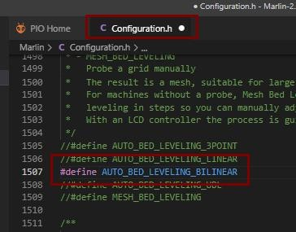

## Set the number of grid points for leveling

Set the number of leveling points in the configuration file, the default is 3*3

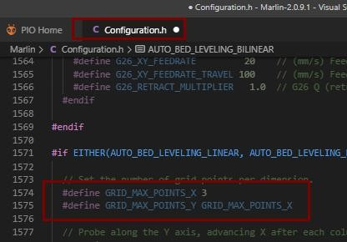

## Enable the servo

Enable the servo in the configuration file

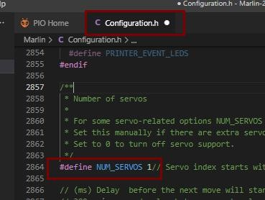

## Add auto-leveling data enable code

Added set_bed_leveling_enabled(true); in G28.cpp file

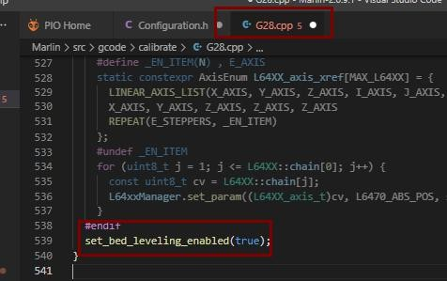

* 1. **enable z_safe_homing**

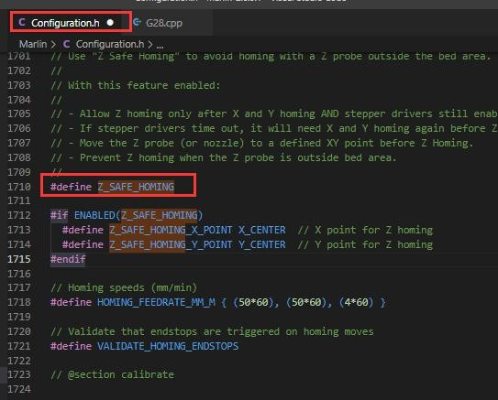

# WEB connection and settings

The firmware has enabled wifi. After the motherboard updates the firmware, the default wifi is AP mode (local area network). At this time, use a computer or mobile phone to view the wifi list, and you can see that the name of the wifi is MARLIN_ESP.

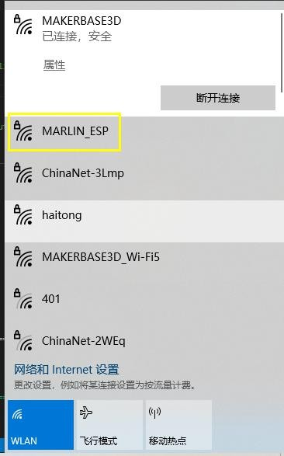

1. Enter the password to connect to wif (the default wifi password is 12345678);

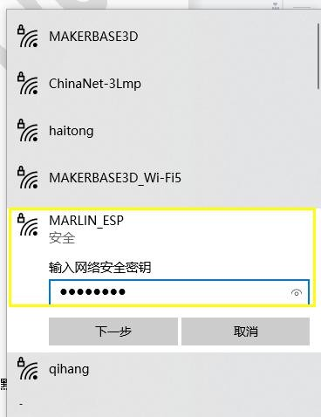

1. in the browser, enter the ip to log in to the web interface (the default ip address is 192.168.0.1);

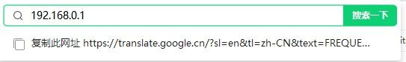

1. 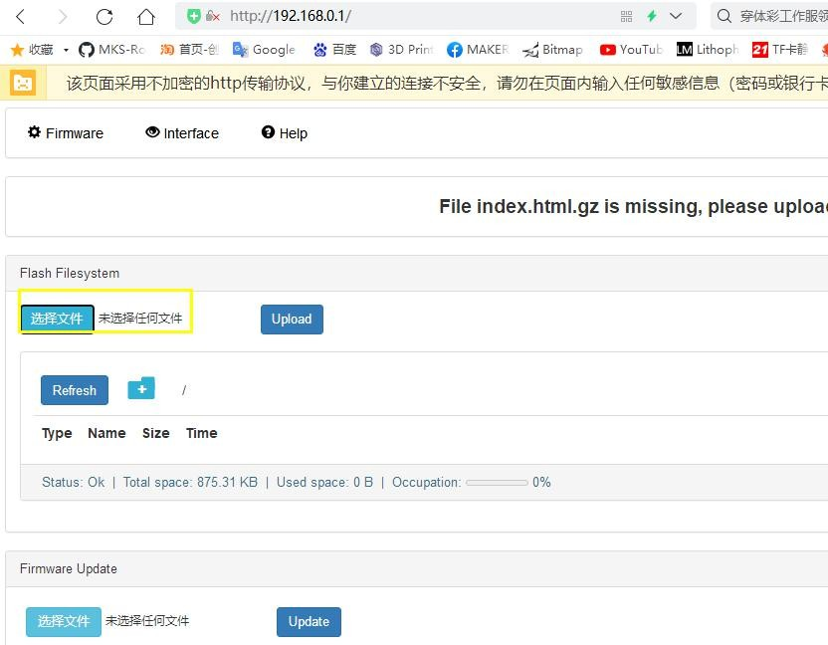Then click to upload the file on the web control interface, the file download link:<https://github.com/luc-github/ESP3DLib>

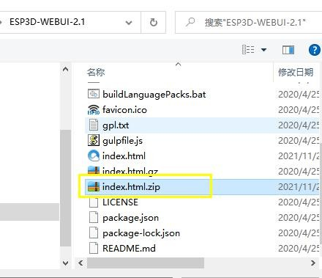

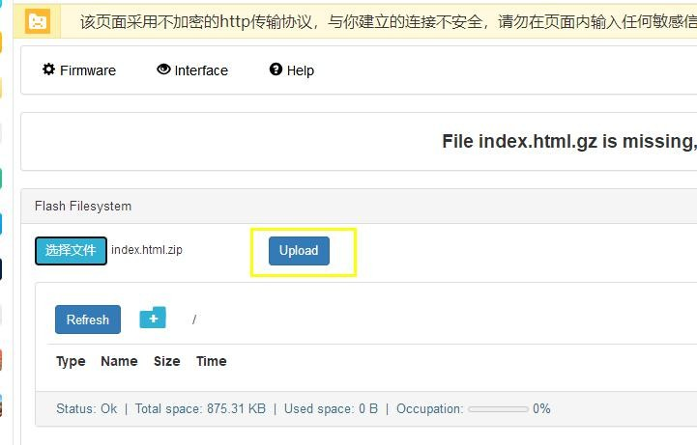

1. After uploading, check the refresh time on the web page, and you can start operation control after seeing the temperature

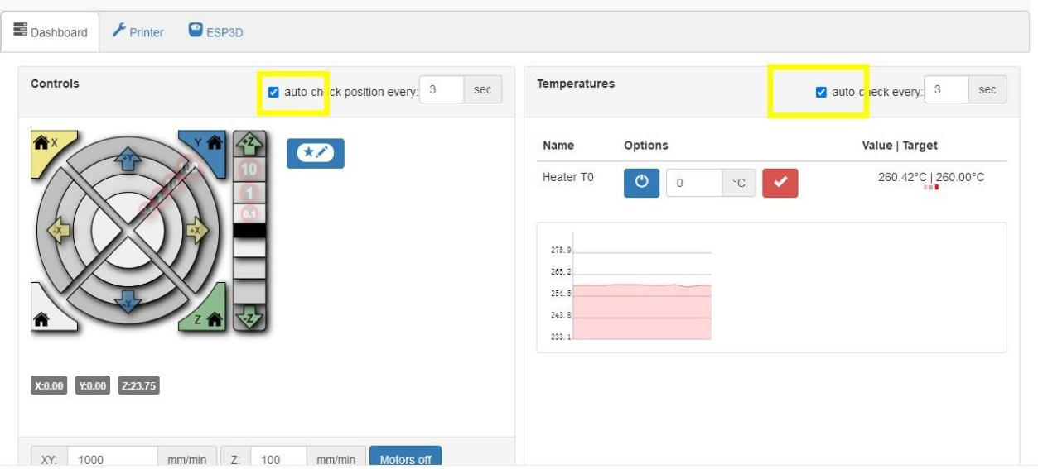

1. STA mode setting, enter the ESP3D interface, then select Client

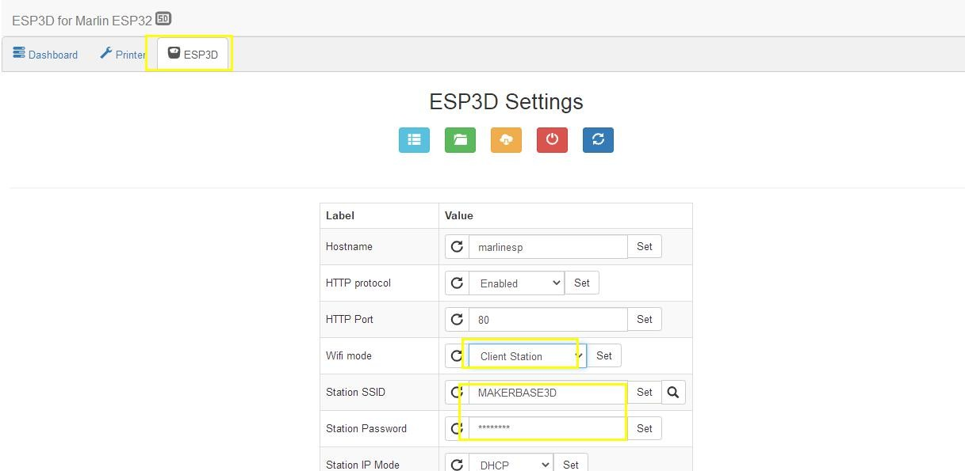Station, enter the name and password of the wifi you want to connect, check set, and then need to restart the motherboard. If you are using LCD, you can view it on the LCD interface To the assigned ip, if you use a serial port screen or a useless screen, you need to log in to the router's management page to view the ip; then re-enter the ip on the browser to enter the web.

# 7、FAQ

1. After updating the firmware, how to deal if the parameters such as pulse and maximum speed displayed on the LCD screen are incorrect? **Answer:** Enter the advanced setting interface on the screen, initialize eeprom, and then return to the setting interface, save data, and load data
2. How to deal with the motherboard cannot be connected to the host computer of the computer？

**Answer:** Confirm whether the serial port of the motherboard in the

configuration file is correct. MKS MONSTER8V1.0 uses serial port-1; After the motherboard is connected to the computer, enter the device manager to check whether the computer recognizes the com port of the motherboard. If so, you can restart the host computer. The baud rate set by the host computer needs to be consistent with the configuration file setting; if it cannot be recognized, check the usb.